83. Aura Method - 04 August 2022

Definition : Aura Method is used to call Child Component JS Controller Method Directly from Parent Component.

Parent 🡪 Child

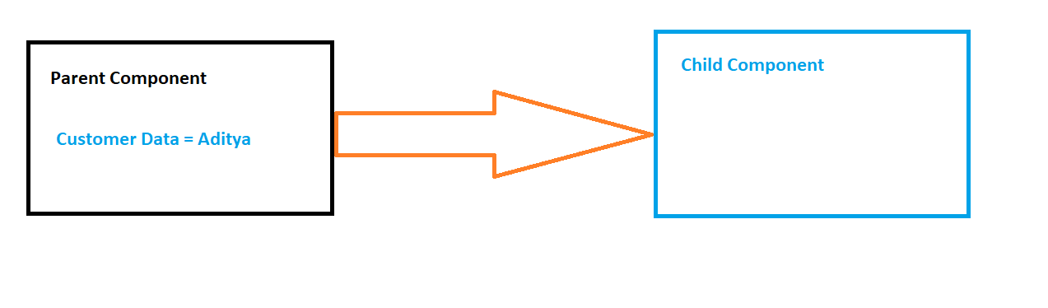

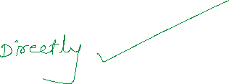

Child (Event) 🡪 Parent

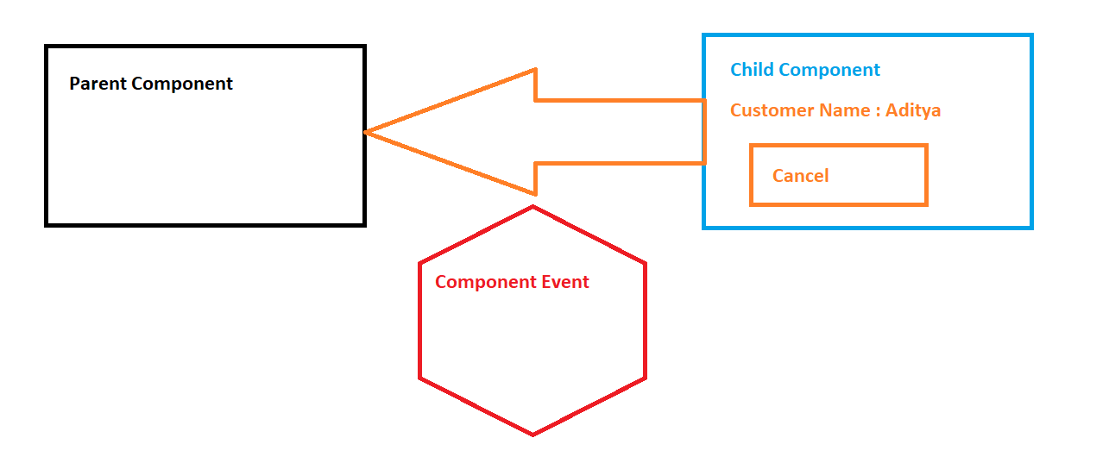



Aura : Method

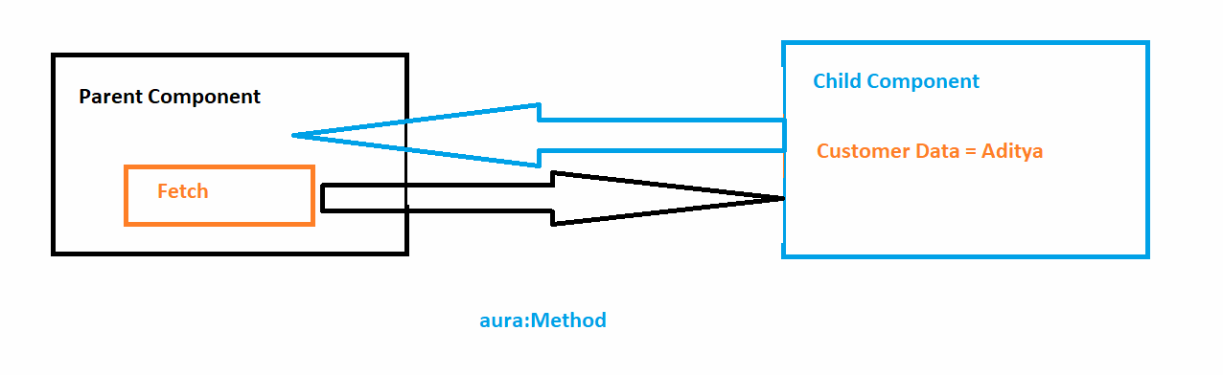



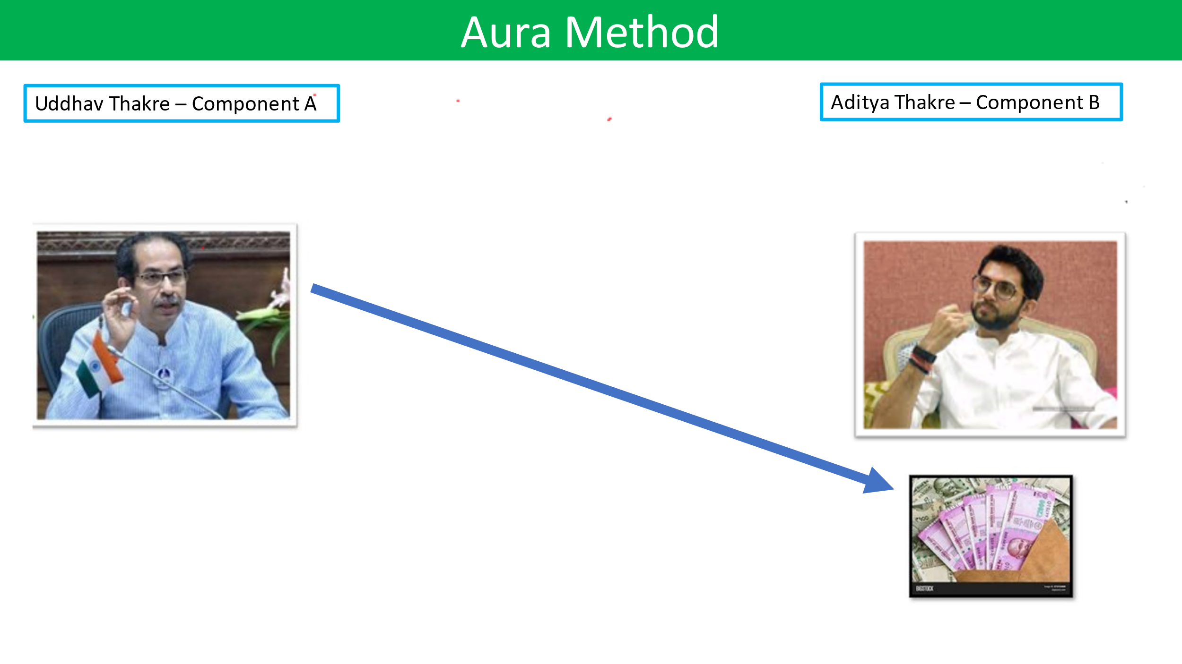

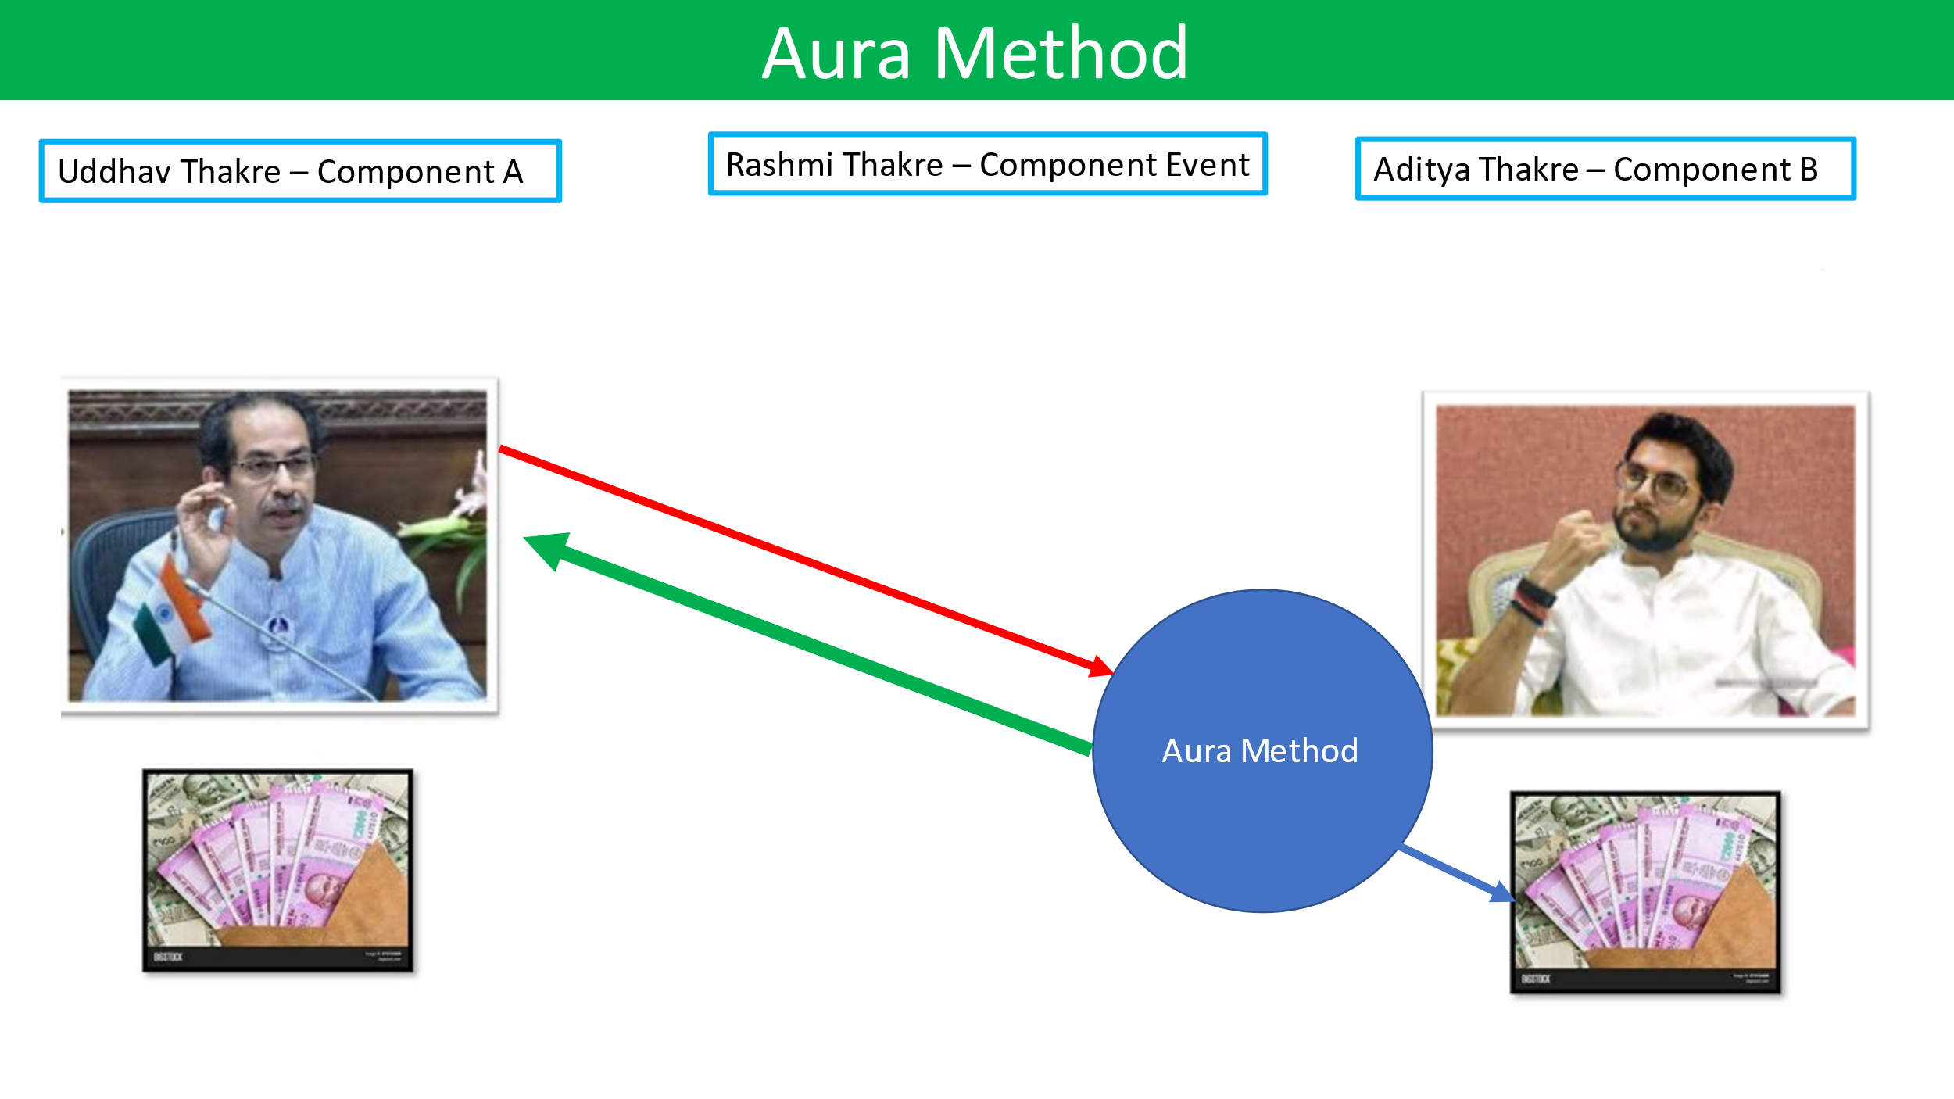

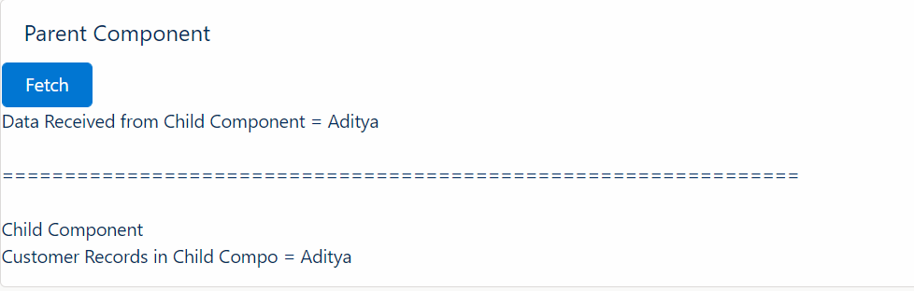

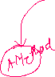

FLOW:

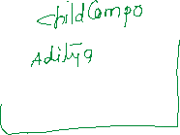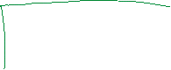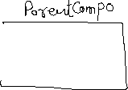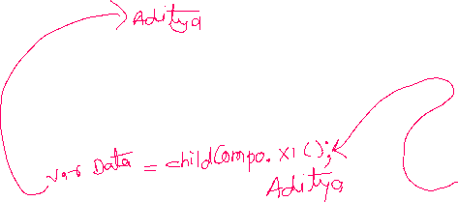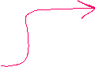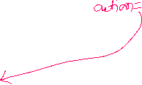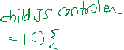

STEPS:

1] 



2] 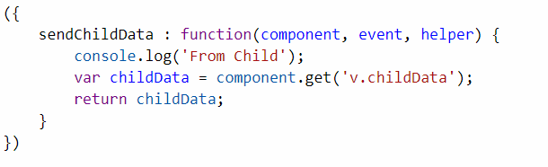

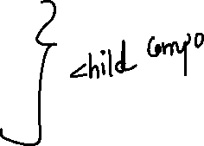

3] Calling Child from Parent : 

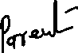

Find Child Compo and Call AURA:Method from JS controller of Parent:

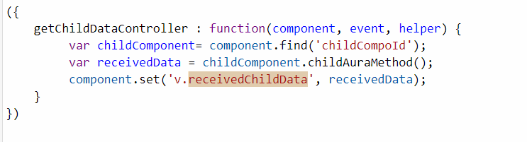



Parent:

<aura:component implements="force:appHostable,flexipage:availableForAllPageTypes,flexipage:availableForRecordHome,force:hasRecordId,forceCommunity:availableForAllPageTypes,force:lightningQuickAction" access="global" >

<aura:attribute name="receivedDataFromChild" type="String" default="Waiting...!!!" />

<lightning:card title="Parent Component">

<lightning:button variant="brand" iconName="utility:send" label="Get Data From Child" onclick="{!c.getChildDataController}" /> <br />

Received Data from Child Component = <ui:outputText value="{!v.receivedDataFromChild}" /><br/>

===================== <br/>

<!--Calling AuraChildCompo -->

<c:AuraChildCompo aura:id="childCompoId"/>

</lightning:card>

</aura:component>

JS Controller:

({

getChildDataController : function(component, event, helper) {

var receivedData = component.find('childCompoId').getChildCustomerName(); //AuraChildCompo ke Aura Method call

console.log("Received = "+receivedData);

component.set('v.receivedDataFromChild', receivedData);

}

})

Child Component:

<aura:component implements="force:appHostable,flexipage:availableForAllPageTypes,flexipage:availableForRecordHome,force:hasRecordId,forceCommunity:availableForAllPageTypes,force:lightningQuickAction" access="global" >

<aura:attribute name="customerName" type="String" default="Aditya" />

<!--Aura Method-->

<aura:method name="getChildCustomerName" action="{!c.returnCustomerNameController}" />

<lightning:card title="Child Component">

Customer Name in Child Component = {!v.customerName}

</lightning:card>

</aura:component>

JS Controller:

({

returnCustomerNameController : function(component, event, helper) {

console.log("Zatka Zala...!!!");

return component.get('v.customerName');

}

})

==================END===========

NOW COMPLETE

1] Test Classes – Videos (03 Days and 05 Videos)

2] JIRA Tool – Video

3] Trigger Integration

CODING TEST: MONDAY 08 Aug 2022 Time: 09:30 PM

Trigger, Batch Class, LWC (Create New Account (LDS, Custom) )

========TRAINING END========